0423111 (4203201)
SOIL MECHANICS
MAKE-UP EXAMINATION
30.01.2014
Student Name:
Q.1 | Q.2 | Q.3 | Q.4 | Q.5 | TOTAL
Number:
Group:

- a) Classify the soils below according to the “Unified Soil Classification System” (USCS) and “Highway Classification System (AASHTO)”.
 | Sieve No: | 4 | 10 | 20 | 40 | 100 | 200 | C_{u} | Cc | LL (%) | PL (%)
Soil A | % Passing | 100 | 78 | 71 | 64 | 60 | 57 | - | - | 55 | 20
Soil B | % Passing | 100 | 85 | 68 | 54 | 42 | 38 | 4.8 | 2.6 | 65 | 44

- i- Write the three-dimensional mathematical equation describing the water flow through soils. What is the name of this equation and what methods are used in solving it?
ii- What are normally consolidated and overconsolidated clays? Explain.
iii- Briefly describe the unconfined compression (UC) test.
iv- What are the factors that affect the in-situ compaction?

- An excavation is planned in the soil profile given below. The water table in a boring to the sand layer indicated that there is an artesian condition up to 10 m above from the top elevation of the sand layer.
  - How deep can the excavation be made without causing a failure at the base of the excavation? (H=?)
  - What is the safety factor of the excavation against failure if the excavation depth (H) is 6 meters?
  - Calculate the pressure, elevation and total hydraulic head at point A.

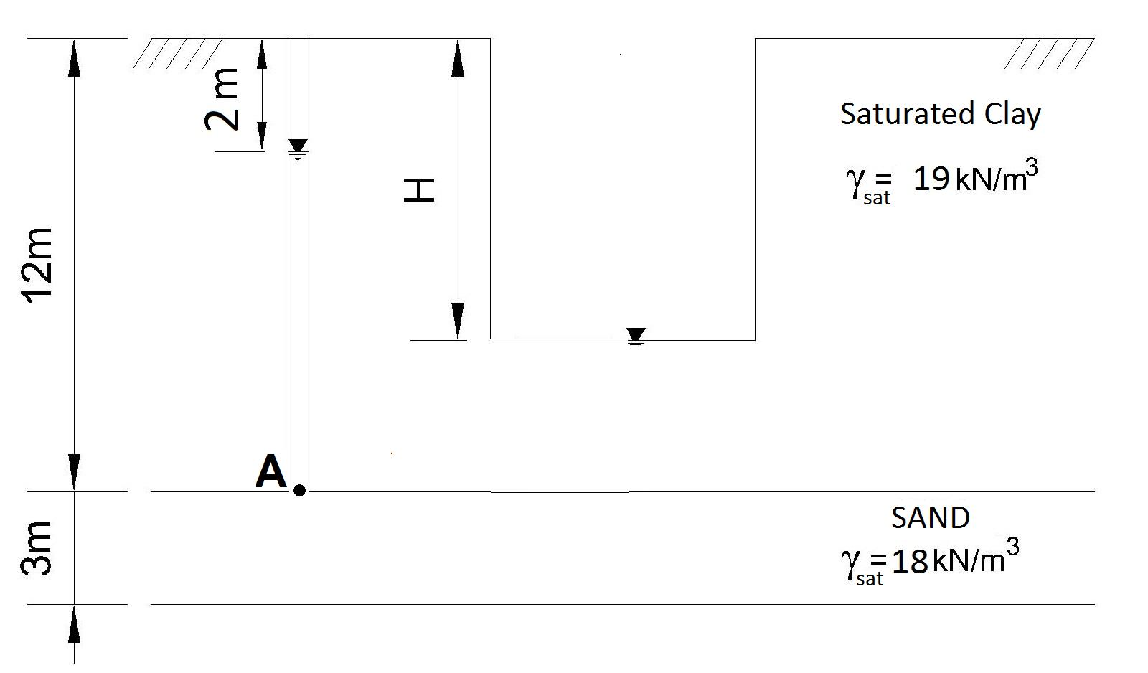

- Consolidated-drained (CD) and consolidated-undrained (CU) triaxial tests are conducted on a sample from a saturated, normally consolidated clay layer where a 160 kPa cell pressure is applied. The results from the tests are as follows:
Test | σ₃ | σ₁- σ₃
CD | 160 | 235
CU | 160 | 165

- Calculate the total and effective shear strength parameters for both CU and CD tests.
- For both tests, determine the pore water pressure developed at failure.
- Draw the Mohr circles and the failure envelopes using the collected data.
- Which of the shear strength parameters should be used for a temporary (short-term) excavation in the clay layer?

- The ground water table is at the surface for the soil profile given below. The consolidation test results on the samples from the clay layers are also given.
a) Calculate the estimated amount of settlement if the water table is dropped 8 meters lower. Assume the soil above the groundwater level to be dry.
- Calculate the settlement after a year if the coefficient of consolidation is c_{v}= 9.1x10⁻⁷ m²/sec.

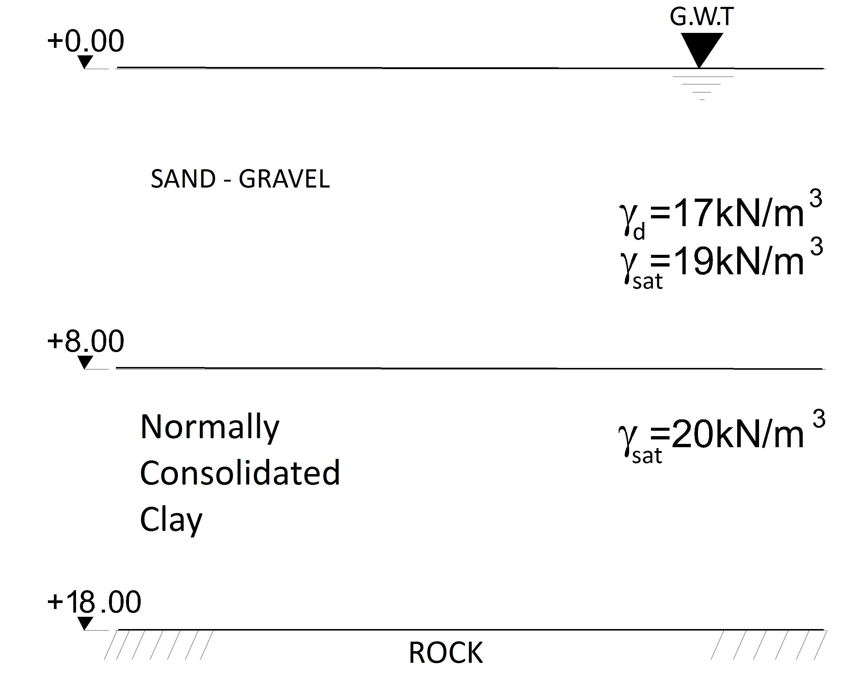

σʹ₀ (kN/m²) | 0 | 25 | 50 | 100 | 200 | 400 | 800
e (void ratio) | 0.91 | 0.89 | 0.87 | 0.86 | 0.82 | 0.77 | 0.72

U (%) | 10 | 20 | 30 | 40 | 50 | 60 | 70 | 80 | 90
T_{v} | 0.008 | 0.031 | 0.071 | 0.126 | 0.197 | 0.287 | 0.408 | 0.567 | 0.848

- Standard Proctor and pycnometer tests are conducted on samples from a silty clay soil with a void ratio (e) of 0.65. The maximum dry unit weight (γ_{d,max}) is found as 17.5 kN/m³ with an optimum water content (w_{opt}) of 15%. The specific gravity (G_{s}) is 2.65.
  - Determine the amount of borrow material (in units of m³) if a 7000 m³ of compacted fill at an optimum water content is planned with a relative compaction (R) of 100%.
  - Determine the volume of water within the 7000 m³ of fill compacted at an optimum water content.

Time: 90 Minutes… Good Luck….

